UNIT-IV
TREES
4.1. Basic Tree concepts
A tree is a data structure made up of nodes or vertices and edges without having any cycle. The tree with no nodes is called the null or empty tree. A tree that is not empty consists of a root node and potentially many levels of additional nodes that form a hierarchy.
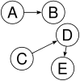
Not a tree: two non-connected parts, A→B and C→D→E. There is more than one root.

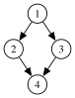
Not a tree: undirected cycle 1-2-4-3. 4 has more than one parent (inbound edge).

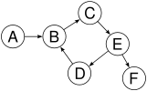
Not a tree: cycle B→C→E→D→B. B has more than one parent (inbound edge).

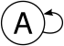
Not a tree: cycle A→A. A is the root but it also has a parent.

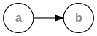
Each linear list is trivially a tree
Root: The top node in a tree.
Child: A node directly connected to another node when moving away from the root.
Parent: The converse notion of a child.
Siblings: A group of nodes with the same parent.
Descendant: A node reachable by repeated proceeding from parent to child.
Ancestor: A node reachable by repeated proceeding from child to parent.
Leaf : External node (not common)
A node with no children.
Branch node
Internal node: A node with at least one child.
Degree: For a given node, its number of children. A leaf is necessarily degree zero.
Edge: The connection between one node and another.
Path: A sequence of nodes and edges connecting a node with a descendant.
Level: The level of a node is defined as: 1 + the number of edges between the node and the root.
Height of node: The height of a node is the number of edges on the longest path between that node and a leaf.
Height of tree: The height of a tree is the height of its root node.
Depth: The depth of a node is the number of edges from the tree's root node to the node.
Forest: A forest is a set of n ≥ 0 disjoint trees.
4.2. Binary Trees
We extend the concept of linked data structures to structure containing nodes with more than one self-referenced field. A binary tree is made of nodes, where each node contains a "left" reference, a "right" reference, and a data element. The topmost node in the tree is called the root.  Every node (excluding a root) in a tree is connected by a directed edge from exactly one other node. This node is called a parent. On the other hand, each node can be connected to arbitrary number of nodes, called children. Nodes with no children are called leaves, or external nodes. Nodes which are not leaves are called internal nodes. Nodes with the same parent are called siblings. | 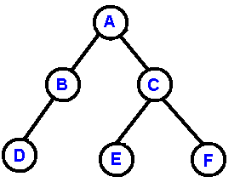
More tree terminology:
- The depth of a node is the number of edges from the root to the node.
- The height of a node is the number of edges from the node to the deepest leaf.
- The height of a tree is a height of the root.
- A full binary tree is a binary tree in which each node has exactly zero or two children.
- A complete binary tree is a binary tree, which is completely filled, with the possible exception of the bottom level, which is filled from left to right.
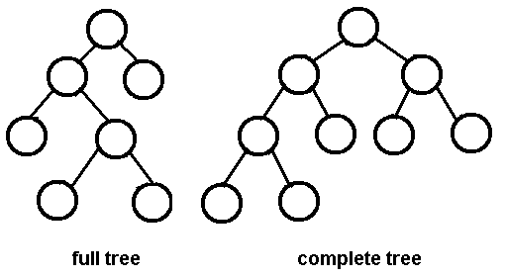
A complete binary tree is very special tree, it provides the best possible ratio between the number of nodes and the height. The height h of a complete binary tree with N nodes is at most O(log N). We can easily prove this by counting nodes on each level, starting with the root, assuming that each level has the maximum number of nodes:
n = 1 + 2 + 4 + ... + 2^{h-1} + 2^{h} = 2^{h+1} - 1
Solving this with respect to h, we obtain
h = O(log n)
where the big-O notation hides some superfluous details.

Advantages of trees
Trees are so useful and frequently used, because they have some very serious advantages:
- Trees reflect structural relationships in the data
- Trees are used to represent hierarchies
- Trees provide an efficient insertion and searching
- Trees are very flexible data, allowing to move subtrees around with minumum effort

Traversals
A traversal is a process that visits all the nodes in the tree. Since a tree is a nonlinear data structure, there is no unique traversal. We will consider several traversal algorithms with we group in the following two kinds
- depth-first traversal
- breadth-first traversal
There are three different types of depth-first traversals, :
- PreOrder traversal - visit the parent first and then left and right children;
- InOrder traversal - visit the left child, then the parent and the right child;
- PostOrder traversal - visit left child, then the right child and then the parent;
There is only one kind of breadth-first traversal--the level order traversal. This traversal visits nodes by levels from top to bottom and from left to right.
As an example consider the following tree and its four traversals:  PreOrder - 8, 5, 9, 7, 1, 12, 2, 4, 11, 3  InOrder - 9, 5, 1, 7, 2, 12, 8, 4, 3, 11  PostOrder - 9, 1, 2, 12, 7, 5, 3, 11, 4, 8  LevelOrder - 8, 5, 4, 9, 7, 11, 1, 12, 3, 2 | 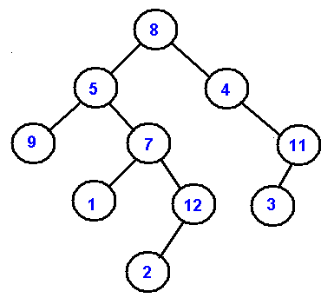
In the next picture we demonstarte the order of node visitation. Number 1 denote the first node in a particular traversal and 7 denote the last node.
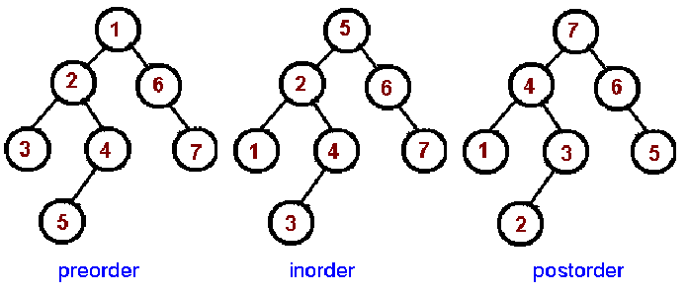
These common traversals can be represented as a single algorithm by assuming that we visit each node three times. An Euler tour is a walk around the binary tree where each edge is treated as a wall, which you cannot cross. In this walk each node will be visited either on the left, or under the below, or on the right. The Euler tour in which we visit nodes on the left produces a preorder traversal. When we visit nodes from the below, we get an inorder traversal. And when we visit nodes on the right, we get a postorder traversal.
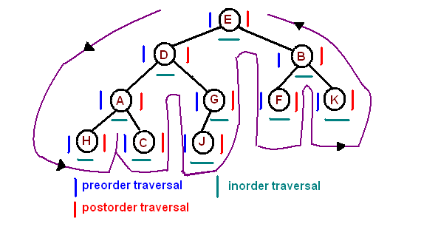
4.3. General Trees
A general tree T is a finite set of one or more nodes such that there is one designated node r, called the root of T, and the remaining nodes are partitioned into n ≥ 0 disjoint subsets T1, T2, …, Tn, each of which is a tree, and whose roots b,c,d respectively, are children of a.

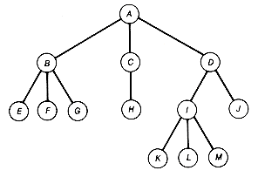
Creating a Binary Tree from a General Tree
Since the references now access either the first child or successive siblings,
the process must use this type of information rather than magnitude as was
the case for the binary search tree. Note that the resulting tree is a
binary tree but not a binary search tree.
The process of converting the general tree to a binary tree is as follows:
* use the root of the general tree as the root of the binary tree
* determine the first child of the root. This is the leftmost node in the
general tree at the next level
* insert this node. The child reference of the parent node refers to this
node
* continue finding the first child of each parent node and insert it below
the parent node with the child reference of the parent to this node.
* when no more first children exist in the path just used, move back to the
parent of the last node entered and repeat the above process. In other
words, determine the first sibling of the last node entered.
* complete the tree for all nodes. In order to locate where the node fits
you must search for the first child at that level and then follow the
sibling references to a nil where the next sibling can be inserted. The
children of any sibling node can be inserted by locating the parent and then
inserting the first child. Then the above process is repeated.

4.4. Binary Search Trees
We consider a particular kind of a binary tree called a Binary Search Tree (BST). The basic idea behind this data structure is to have such a storing repository that provides the efficient way of data sorting, searching and retrieving.
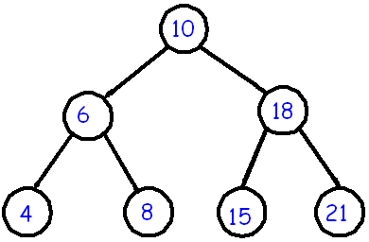 | A BST is a binary tree where nodes are ordered in the following way:  - each node contains one key (also known as data)  - the keys in the left subtree are less then the key in its parent node, in short L < P;  - the keys in the right subtree are greater the key in its parent node, in short P < R;  - duplicate keys are not allowed.  In the following tree all nodes in the left subtree of 10 have keys < 10 while all nodes in the right subtree > 10. Because both the left and right subtrees of a BST are again search trees; the above definition is recursively applied to all internal nodes:

4.5. BST Operations

Insertion
The insertion procedure is quite similar to searching. We start at the root and recursively go down the tree searching for a location in a BST to insert a new node. If the element to be inserted is already in the tree, we are done (we do not insert duplicates). The new node will always replace a NULL reference.
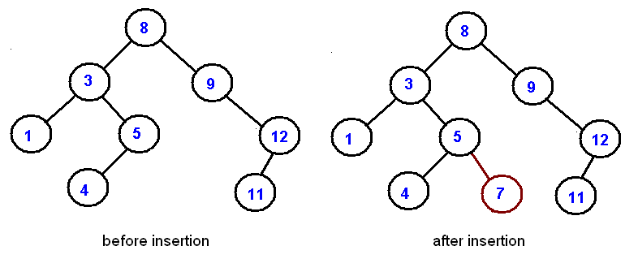
Exercise. Given a sequence of numbers:
11, 6, 8, 19, 4, 10, 5, 17, 43, 49, 31
Draw a binary search tree by inserting the above numbers from left to right.
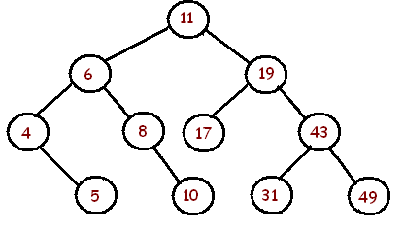

Searching
Searching in a BST always starts at the root. We compare a data stored at the root with the key we are searching for (let us call it as to Search). If the node does not contain the key we proceed either to the left or right child depending upon comparison. If the result of comparison is negative we go to the left child, otherwise - to the right child. The recursive structure of a BST yields a recursive algorithm.
Searching in a BST has O(h) worst-case runtime complexity, where h is the height of the tree. Since s binary search tree with n nodes has a minimum of O(log n) levels, it takes at least O(log n) comparisons to find a particular node. Unfortunately, a binary search tree can degenerate to a linked list, reducing the search time to O(n).

Deletion
Deletion is somewhat more tricky than insertion. There are several cases to consider. A node to be deleted (let us call it as toDelete)
- is not in a tree;
- is a leaf;
- has only one child;
- has two children.
If toDelete is not in the tree, there is nothing to delete. If toDelete node has only one child the procedure of deletion is identical to deleting a node from a linked list - we just bypass that node being deleted
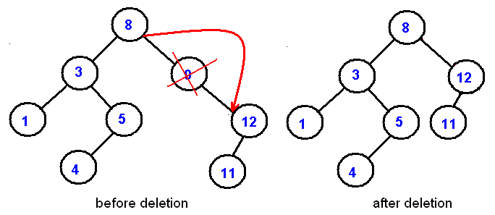
Deletion of an internal node with two children is less straightforward. If we delete such a node, we split a tree into two subtrees and therefore, some children of the internal node won't be accessible after deletion. In the picture below we delete 8:
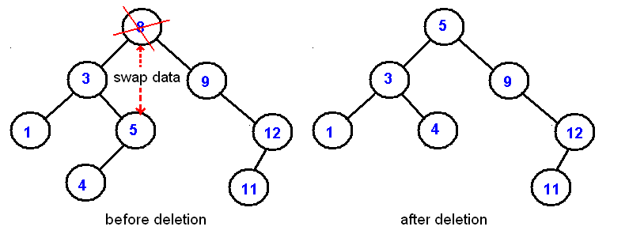
Deletion starategy is the following: replace the node being deleted with the largest node in the left subtree and then delete that largest node. By symmetry, the node being deleted can be swapped with the smallest node is the right subtree.
See BST.java for a complete implementation.
Exercise. Given a sequence of numbers:
11, 6, 8, 19, 4, 10, 5, 17, 43, 49, 31
Draw a binary search tree by inserting the above numbers from left to right and then show the two trees that can be the result after the removal of 11.
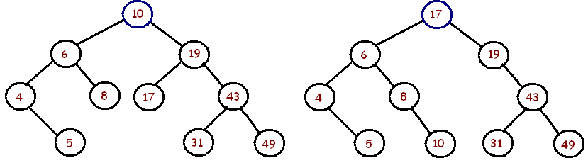

Non-Recursive Traversals
Depth-first traversals can be easily implemented recursively.A non-recursive implementation is a bit more difficult. In this section we implement a pre-order traversal as a tree iterator
public Iterator<AnyType> iterator()
{
return new PreOrderIterator();
}
where the PreOrderIterator class is implemented as an inner private class of the BST class
private class PreOrderIterator implements Iterator<AnyType>
{
...
}
The main difficulty is with next() method, which requires the implicit recursive stack implemented explicitly. We will be using Java's Stack. The algorithm starts with the root and push it on a stack. When a user calls for the next() method, we check if the top element has a left child. If it has a left child, we push that child on a stack and return a parent node. If there is no a left child, we check for a right child. If it has a right child, we push that child on a stack and return a parent node. If there is no right child, we move back up the tree (by popping up elements from a stack) until we find a node with a right child. Here is the next() implementation
public AnyType next()
{
Node cur = stk.peek();
if(cur.left != null)
{
stk.push(cur.left);
}
else
{
Node tmp = stk.pop();
while(tmp.right == null)
{
if (stk.isEmpty()) return cur.data;
tmp = stk.pop();
}
stk.push(tmp.right);
}
return cur.data;
}
The following example.shows the output and the state of the stack during each call to next(). Note, the algorithm works on any binary trees, not necessarily binary search trees..
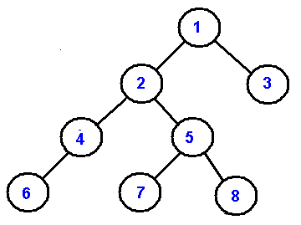
Output |  | 1 | 2 | 4 | 6 | 5 | 7 | 8 | 3
Stack | 1 | 2  1 | 4  2  1 | 6  4  2  1 | 5  1 | 7  5  1 | 8  1 | 3
A non-recursive preorder traversal can be eloquently implemented in just three lines of code. If you understand next()'s implementation above, it should be no problem to grasp this one:
public AnyType next()
{
if (stk.isEmpty()) throw new java.util.NoSuchElementException();

Node cur = stk.pop();
if(cur.right != null) stk.push(cur.right);
if(cur.left != null) stk.push(cur.left);

return cur.data;
}
Note, we push the right child before the left child.

Level Order Traversal
Level order traversal processes the nodes level by level. It first processes the root, and then its children, then its grandchildren, and so on. Unlike the other traversal methods, a recursive version does not exist.
A traversal algorithm is similar to the non-recursive preorder traversal algorithm. The only difference is that a stack is replaced with a FIFO queue.
4.6. BST ADT
We implement a binary search tree using a private inner class BSTNode. In order to support the binary search tree property, we require that data stored in each node is Comparable:
public class BST <AnyType extends Comparable<AnyType>>
{
private Node<AnyType> root;

private class Node<AnyType>
{
private AnyType data;
private Node<AnyType> left, right;

public Node(AnyType data)
{
left = right = null;
this.data = data;
}
}
...

}

4.7. BST Applications
Tree sort
A binary search tree can be used to implement a simple sorting algorithm. Similar to heapsort, we insert all the values we wish to sort into a new ordered data structure—in this case a binary search tree—and then traverse it in order.
The worst-case time of build_binary_tree is O(n²)—if you feed it a sorted list of values, it chains them into a linked list with no left subtrees.
For example, build_binary_tree([1, 2, 3, 4, 5]) yields the tree (1 (2 (3 (4 (5))))).
There are several schemes for overcoming this flaw with simple binary trees; the most common is the self-balancing binary search tree. If this same procedure is done using such a tree, the overall worst-case time is O(n log n), which is asymptotically optimal for a comparison sort. In practice, the added overhead in time and space for a tree-based sort (particularly for node allocation) make it inferior to other asymptotically optimal sorts such as heapsort for static list sorting. On the other hand, it is one of the most efficient methods of incremental sorting, adding items to a list over time while keeping the list sorted at all times.
Priority queue operations
Binary search trees can serve as priority queues: structures that allow insertion of arbitrary key as well as lookup and deletion of the minimum (or maximum) key. Insertion works as previously explained. Find-min walks the tree, following left pointers as far as it can without hitting a leaf:
// Precondition: T is not a leaf
function find-min(T):
while hasLeft(T):
T ? left(T)
return key(T)
Find-max is analogous: follow right pointers as far as possible. Delete-min (max) can simply look up the minimum (maximum), then delete it. This way, insertion and deletion both take logarithmic time, just as they do in a binary heap, but unlike a binary heap and most other priority queue implementations, a single tree can support all of find-min, find-max, delete-min and delete-max at the same time, making binary search trees suitable as double-ended priority queues.
4.8. Threaded Trees
Inorder traversal of a Binary tree can either be done using recursion or with the use of a auxiliary stack. The idea of threaded binary trees is to make inorder traversal faster and do it without stack and without recursion. A binary tree is made threaded by making all right child pointers that would normally be NULL point to the inorder successor of the node (if it exists).

There are two types of threaded binary trees.
Single Threaded: Where a NULL right pointers is made to point to the inorder successor (if successor exists)

Double Threaded: Where both left and right NULL pointers are made to point to inorder predecessor and inorder successor respectively. The predecessor threads are useful for reverse inorder traversal and postorder traversal.

The threads are also useful for fast accessing ancestors of a node.
Following diagram shows an example Single Threaded Binary Tree. The dotted lines represent threads.
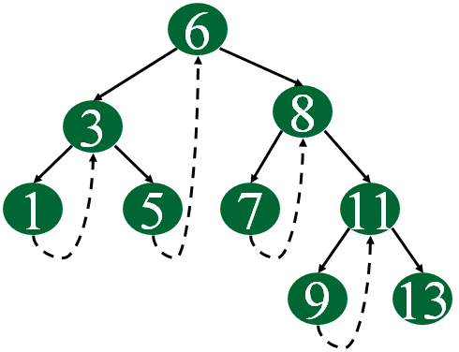
C representation of a Threaded Node
Following is C representation of a single threaded node.
struct Node
{
int data;
Node *left, *right;
bool rightThread;
}

Run on IDE

Since right pointer is used for two purposes, the boolean variable rightThread is used to indicate whether right pointer points to right child or inorder successor. Similarly, we can add leftThread for a double threaded binary tree.
Inorder Taversal using Threads
Following is C code for inorder traversal in a threaded binary tree.
// Utility function to find leftmost node in a tree rooted with n
struct Node* leftMost(struct Node *n)
{
if (n == NULL)
return NULL;

while (n->left != NULL)
n = n->left;

return n;
}

// C code to do inorder traversal in a threaded binary tree
void inOrder(struct Node *root)
{
struct Node *cur = leftmost(root);
while (cur != NULL)
{
printf("%d ", cur->data);

// If this node is a thread node, then go to
// inorder successor
if (cur->rightThread)
cur = cur->rightThread;
else // Else go to the leftmost child in right subtree
cur = leftmost(cur->right);
}
}

Run on IDE
Following diagram demonstrates inorder order traversal using threads.
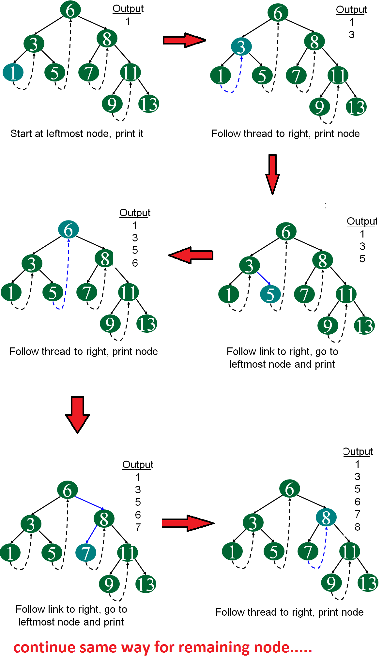
4.9. AVL Tree
AVL tree is a self balanced binary search tree. That means, an AVL tree is also a binary search tree but it is a balanced tree. A binary tree is said to be balanced, if the difference between the hieghts of left and right subtrees of every node in the tree is either -1, 0 or +1. In other words, a binary tree is said to be balanced if for every node, height of its children differ by at most one. In an AVL tree, every node maintains a extra information known as balance factor. The AVL tree was introduced in the year of 1962 by G.M. Adelson-Velsky and E.M. Landis.
An AVL tree is defined as
An AVL tree is a balanced binary search tree. In an AVL tree, balance factor of every node is either -1, 0 or +1.
Balance factor of a node is the difference between the heights of left and right subtrees of that node. The balance factor of a node is calculated either height of left subtree - height of right subtree (OR) height of right subtree - height of left subtree. In the following explanation, we are calculating as follows...
Balance factor = heightOfLeftSubtree - heightOfRightSubtree

Example
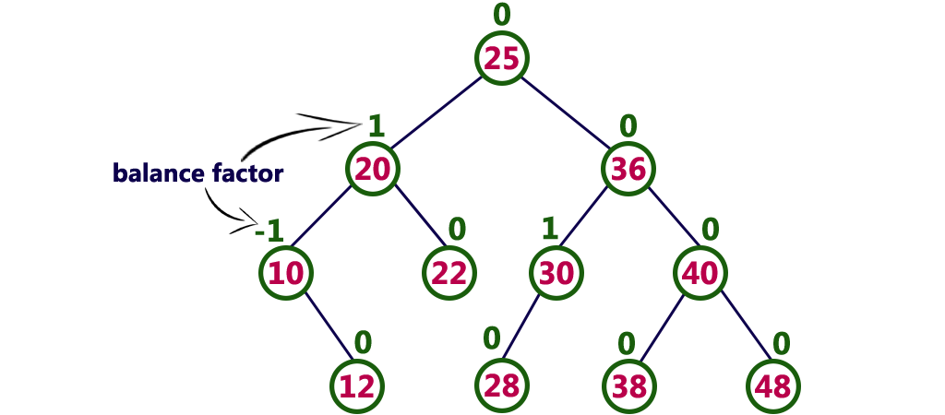
The above tree is a binary search tree and every node is satisfying balance factor condition. So this tree is said to be an AVL tree.
Every AVL Tree is a binary search tree but all the Binary Search Trees need not to be AVL trees.

AVL Tree Rotations
In AVL tree, after performing every operation like insertion and deletion we need to check the balance factor of every node in the tree. If every node satisfies the balance factor condition then we conclude the operation otherwise we must make it balanced. We use rotation operations to make the tree balanced whenever the tree is becoming imbalanced due to any operation.
Rotation operations are used to make a tree balanced.
Rotation is the process of moving the nodes to either left or right to make tree balanced.
There are four rotations and they are classified into two types.
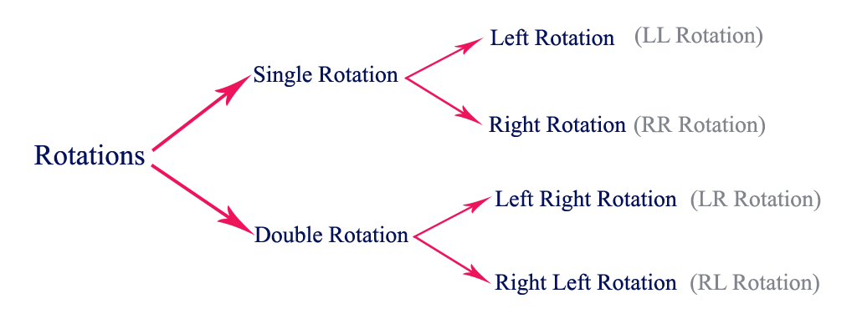

Single Left Rotation (LL Rotation)
In LL Rotation every node moves one position to left from the current position. To understand LL Rotation, let us consider following insertion operations into an AVL Tree...
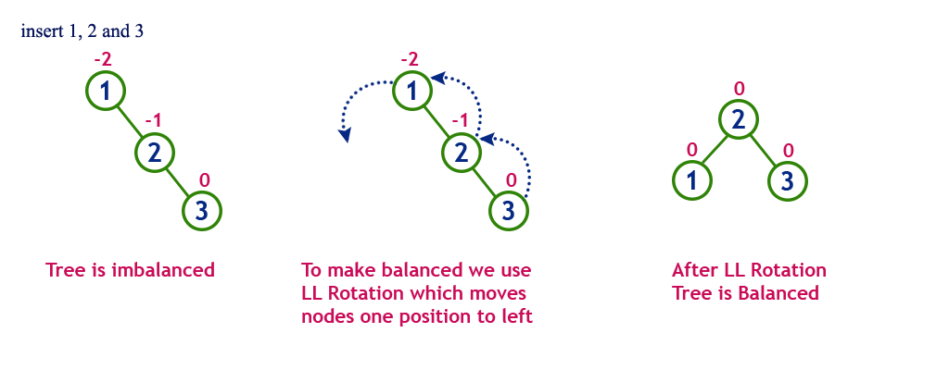

Single Right Rotation (RR Rotation)
In RR Rotation every node moves one position to right from the current position. To understand RR Rotation, let us consider following insertion operations into an AVL Tree...
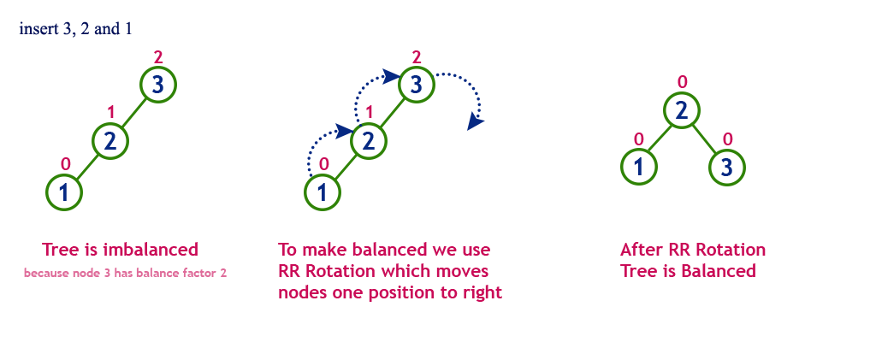

Left Right Rotation (LR Rotation)
The LR Rotation is combination of single left rotation followed by single right rotation. In LR Roration, first every node moves one position to left then one position to right from the current position. To understand LR Rotation, let us consider following insertion operations into an AVL Tree...
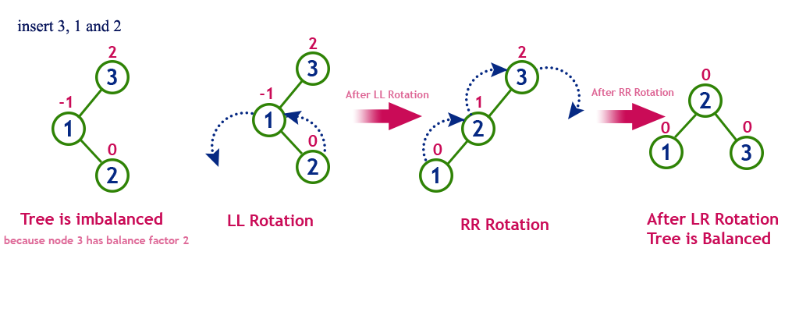

Right Left Rotation (RL Rotation)
The RL Rotation is combination of single right rotation followed by single left rotation. In RL Rotation, first every node moves one position to right then one position to left from the current position. To understand RL Rotation, let us consider following insertion operations into an AVL Tree...
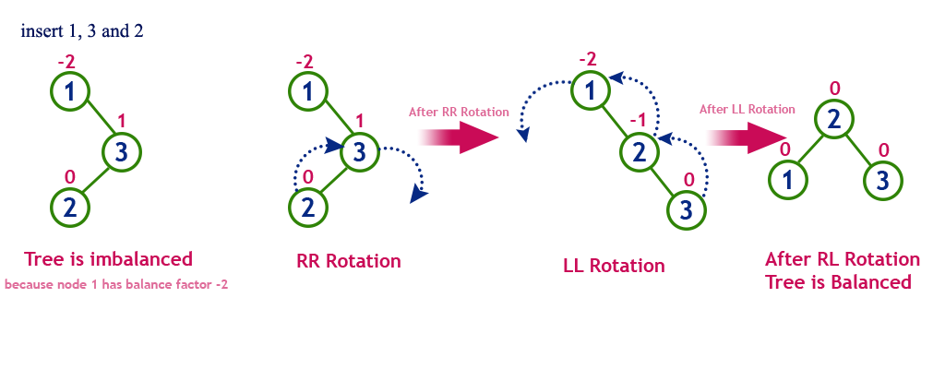

Operations on an AVL Tree
The following operations are performed on an AVL tree...
- Search
- Insertion
- Deletion

Search Operation in AVL Tree
In an AVL tree, the search operation is performed with O(log n) time complexity. The search operation is performed similar to Binary search tree search operation. We use the following steps to search an element in AVL tree...
- Step 1: Read the search element from the user
- Step 2: Compare, the search element with the value of root node in the tree.
- Step 3: If both are matching, then display "Given node found!!!" and terminate the function
- Step 4: If both are not matching, then check whether search element is smaller or larger than that node value.
- Step 5: If search element is smaller, then continue the search process in left subtree.
- Step 6: If search element is larger, then continue the search process in right subtree.
- Step 7: Repeat the same until we found exact element or we completed with a leaf node
- Step 8: If we reach to the node with search value, then display "Element is found" and terminate the function.
- Step 9: If we reach to a leaf node and it is also not matching, then display "Element not found" and terminate the function.

Deletion Operation in AVL Tree
In an AVL Tree, the deletion operation is similar to deletion operation in BST. But after every deletion operation we need to check with the Balance Factor condition. If the tree is balanced after deletion then go for next operation otherwise perform the suitable rotation to make the tree Balanced.

Insertion Operation in AVL Tree
In an AVL tree, the insertion operation is performed with O(log n) time complexity. In AVL Tree, new node is always inserted as a leaf node. The insertion operation is performed as follows...
- Step 1: Insert the new element into the tree using Binary Search Tree insertion logic.
- Step 2: After insertion, check the Balance Factor of every node.
- Step 3: If the Balance Factor of every node is 0 or 1 or -1 then go for next operation.
- Step 4: If the Balance Factor of any node is other than 0 or 1 or -1 then tree is said to be imbalanced. Then perform the suitable Rotation to make it balanced. And go for next operation.

Example: Construct an AVL Tree by inserting numbers from 1 to 8.

